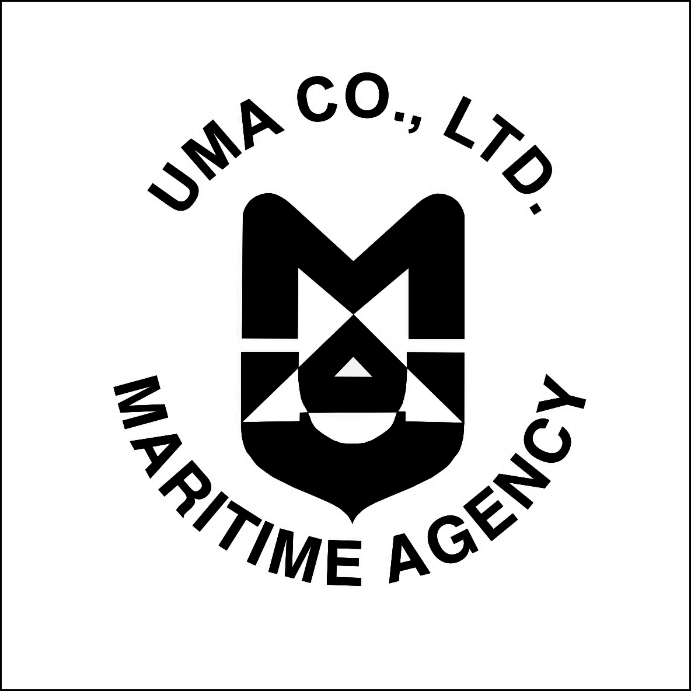
United Maritime Agency Co., Ltd.
16, Sovetskaya Str. Building 2, office 46, Moscow Region, Shchelkovo, Russian Federation, 141100
tel: +7 926 916 80 09
e-mail: uma@mau.com.ru
web site: www.mau.com.ru

APPLICATION FORM (O)

photo

 | Name
 | Position
 | Home address
 | Tel. Number, E-mail
 | Date of birth
 | Place of birth
 | Tourist passport
 | Citizenship
 | Marital status
 | Education:
 | Period |  | Training courses: |  |  |  | Qualification:
 | Work experience:
 | Period |  | Place of employment | Position |  | Activity description
 | From | Till | Place of employment
 | Language skills:

